**WEEK 2 ASSIGNMENT**

**1.create update delete command in mysql**

CREATE DATABASE Employesbook;

USE Employesbook;

CREATE TABLE employees (

id INT PRIMARY KEY AUTO_INCREMENT,

name VARCHAR(50) NOT NULL,

age INT,

email VARCHAR(50)

);

UPDATE employees

SET age = 30, email = 'updated@example.com'

WHERE id = 1;

DELETE FROM employees

WHERE id = 1;

**2.create table and perform joins in mysql**

CREATE DATABASE Employeebookss;

USE Employeebookss;

CREATE TABLE customers (

customer_id INT PRIMARY KEY,

customer_name VARCHAR(50),

email VARCHAR(50)

);

CREATE TABLE orders (

order_id INT PRIMARY KEY,

customer_id INT,

order_date DATE,

total_amount DECIMAL(10, 2),

FOREIGN KEY (customer_id) REFERENCES customers(customer_id)

);

-- Inner Join

SELECT customers.customer_id, customers.customer_name, orders.order_id, orders.order_date

FROM customers

INNER JOIN orders ON customers.customer_id = orders.customer_id;

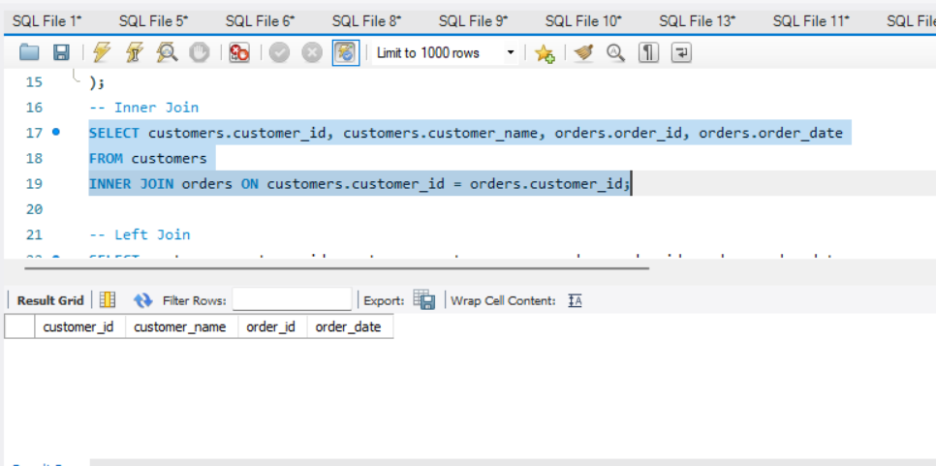

-- Left Join

SELECT customers.customer_id, customers.customer_name, orders.order_id, orders.order_date

FROM customers

LEFT JOIN orders ON customers.customer_id = orders.customer_id;

-- Right Join

SELECT customers.customer_id, customers.customer_name, orders.order_id, orders.order_date

FROM customers

RIGHT JOIN orders ON customers.customer_id = orders.customer_id;

3.using mongo perform create update and delete

Create

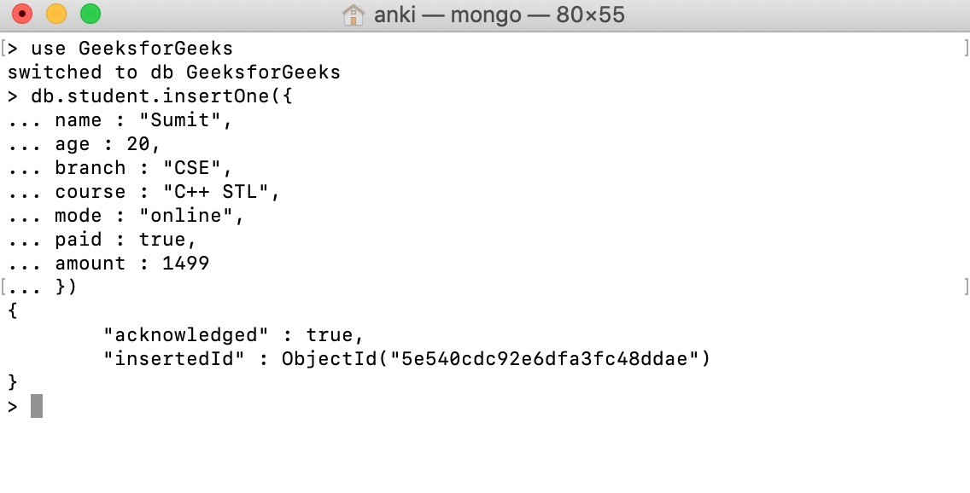

Update

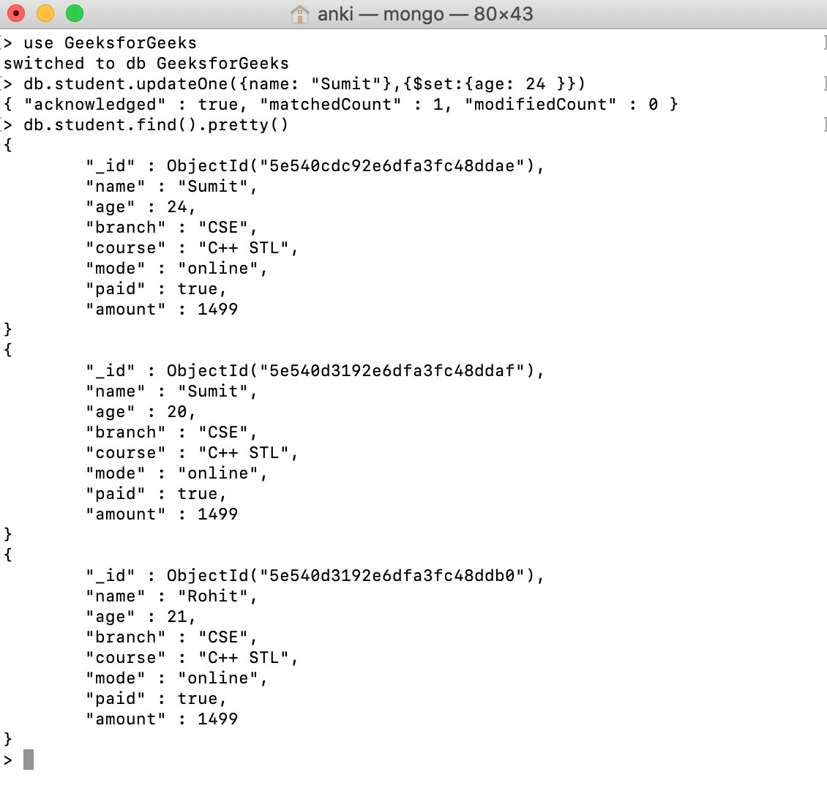

Delete

